OCA Review questions
Chapter 1 – Java building blocks

- Which of the following are valid Java identifiers ? (Choose all that apply)
  - A$B
  - _helloWorld
  - true
  - java.lang
  - Public // also correct
  - 1980_s
- What is the output of the following program
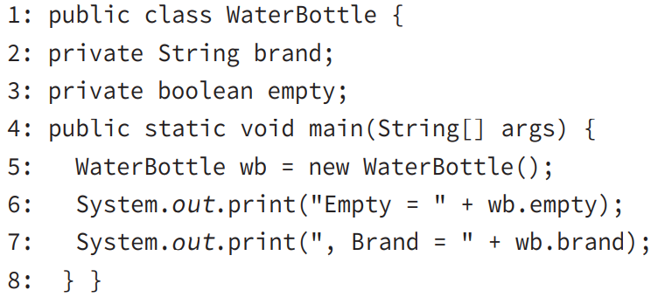

- Line 6 generates a compiler error
- Line 7 generates a compiler error
- There is no output
- Empty = false , Brand = null
- Empty = false , Brand =
- Empty = null , Brand = null

3. Which of the following are true ?
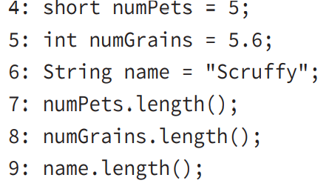

- Line 4 generates a compiler error
- Line 5 generates a compiler error
- Line 6 generates a compiler error
- Line 7 generates a compiler error
- Line 8 generates a compiler error
- Line 9 generates a compiler error
- The code compiles as is

4. Given the following class , which of the following is true ?

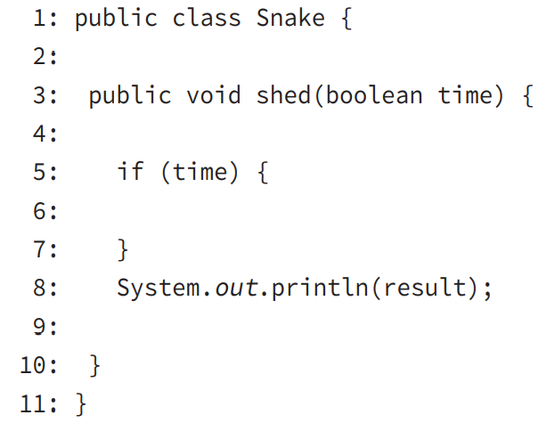
- If String result = "done"; is inserted on line 2, the code will compile // true
- If String result = "done"; is inserted on line 4, the code will compile // true
- If String result = "done"; is inserted on line 6, the code will compile
- If String result = "done"; is inserted on line 9, the code will compile
- None of the above changes will make the code compile

5. Given the following classes which of the follwing can replace INSERT IMPORTS HERE to make the code compile ?
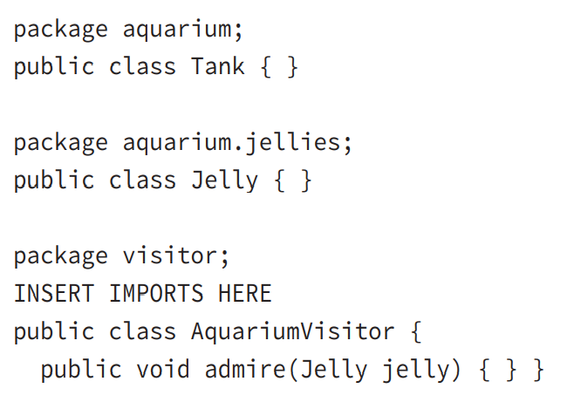
- import aquarim.*;
- import aquarim.*.Jelly;
- import aquarium.jellies.Jelly;
- import aquarium.jellies.*;
- import aquarium.jellies.Jelly.*;
- None of these can make the code compile.

6. Given the following classes , what is the maximum number of imports that can be removed and have the code still compile?
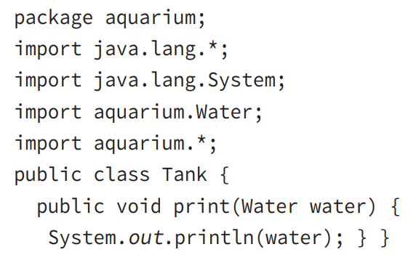
- 0
- 1
- 2
- 3
- 4
- Does not compile

7. Given the following classes, which of the following snippets can be inserted in place of INSERT IMPORTS HERE and have the code compile ?

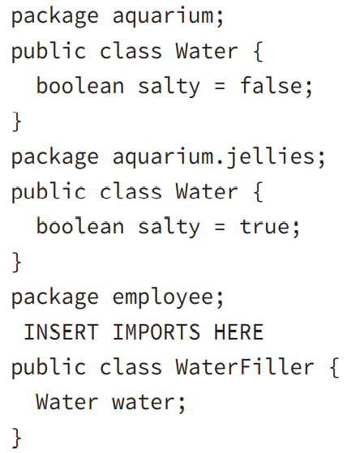
- import aquarium.*;
- import aquarium.Water;
import aquarium.jellies.*;
- import aquarium.*;
import aquarium.jellies.Water;
- import aquarium.*;
import aquarium.jellies.*;
- import aquarium.Water;
import aquarium.jellies.Water;
- None of these import can make the code compile

8. Given the following class ,which of the following calls print out Blue Jay ?
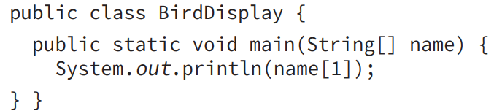

- java BirdDisplay Sparrow Blue Jay
- java BirdDisplay Sparrow “Blue Jay”
- java BirdDisplay “Blue Jay” Sparrow
- java BirdDisplay.class Sparrow “Blue Jay”
- java BirdDisplay.class “Blue Jay” Sparrow
- Does not compile

9. Which of the following legally fill in the blank so you can run the main() method from the command line ?
public static void main(______________)
- String[] _names
- String[] 123
- String abc[]
- String _Names[]
- String … $n
- String names
- None of the above
10. Which of the following are legal entry points that can be run from the command line ?
- private static void main (String[] args) // a main method can be declared private but cannot be ran from the cmd ig
- public static final main (String[] args)
- public void main(String[] args)
- public static void test(String[] args)
- public static void main(String[] args)
- public static main(String[] args)
- None of the above

11. Which of the following are true ?

- An instance variable of type double defaults to null
- An instance variable of type int defaults to null
- An instance variable of type String defaults to null
- An instance variable of type double defaults to 0.0
- An instance variable of type int defaults to 0.0
- An instance variable String defaults to 0.0
- None of the above

12. Which of the following are true ?

- A local variable of type boolean defaults to null
- A local variable of type float defaults to 0
- A local variable of type Object defaults to null
- A local variable of type boolean defaults to false
- A local variable of type boolean defaults to true
- A local variable of type float defaults to 0.0
- None of the above

13. Which of the following are true ?
- An instance variable of type boolean defaults to false
- An instance variable of type boolean defaults to true
- An instance variable of type boolean defaults to null
- An instance variable of type int defaults to 0
- An instance variable of type int defaults to 0.0
- An instance variable of type defaults to null
- None of the above

14. Given the following class in the file my/directory/named/A/Bird.java:
INSERT CODE HERE
public class Bird {}

Which of the following replaces INSERT CODE HERE if we compile from my/directory ?

- package my.directory.named.a;
- package my.directory.named.A;
- package named.a;
- package named.A;
- package a;
- package A;
- Does not compile
15. Which of the following lines of code compile ?

- int i1 = 1_234;
- double d1 = 1_234_.0;
- double d2 = 1_234._0;
- double d3 = 1_234.0_;
- double d4 = 1_234.0;
- None of the above
16. Given the following class which of the following lines of code can replace INSERT CODE HERE to make the code compile ?
public class Price {
public void admission() {
INSERT CODE HERE
System.out.println(amount);
}
}
- int amount = 9L;
- int amount = 0b101;
- int amount = 0xE;
- double amount = 0xE;
- double amount = 1_2_.0_0;
- int amount = 1_2_;
- None of the above

17) Which of the following are true ?
public class Bunny {
public static void main(String[] args) {
Bunny bun = new Bunny();
}
}
- Bunny is a class
- bun is a class
- main is a class
- Bunny is a reference to an object
- bun is a reference to an object
- main is a reference to an object
- None of the above

18. Which represent the order in which the following statements can be assembled into a program that will compile successfully ?
A: class Rabbit {}
B: import java.util.*;
C: package animals;

- A,B,C
- B,C,A
- C,B,A
- B,A
- C,A
- A,C
- A,B
19. Suppose a class named Rabbit. Which of the following statements are true ?
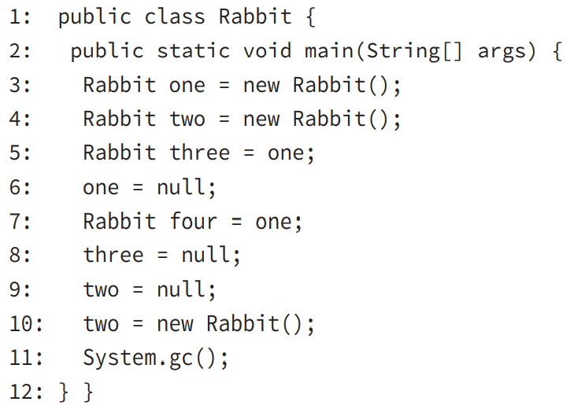

A. The Rabbit object from line 3 is first eligible for garbage collection immediately following line 6.
B. The Rabbit object from line 3 is first eligible for garbage collection immediately following line 8. C. The Rabbit object from line 3 is first eligible for garbage collection immediately following line 12. D. The Rabbit object from line 4 is first eligible for garbage collection immediately following line 9.
E. The Rabbit object from line 4 is first eligible for garbage collection immediately following line 11. F. The Rabbit object from line 4 is first eligible for garbage collection immediately following line 12.

20. What is true about the following code ?
public class Bear {
protected void finalize() {
System.out.println("Roar!");
}
public static void main(String[] args) {
Bear bear = new Bear();
bear = null;
System.gc();
} }

- finalize() is guaranteed to be called
- finalize() might or might not be called
- finalize() is guaranteed not to be called
- Garbage collection is guaranteed to run
- Garbage collection might or might not run
- Garbage collection is guaranteed not to run
- The code does not compile
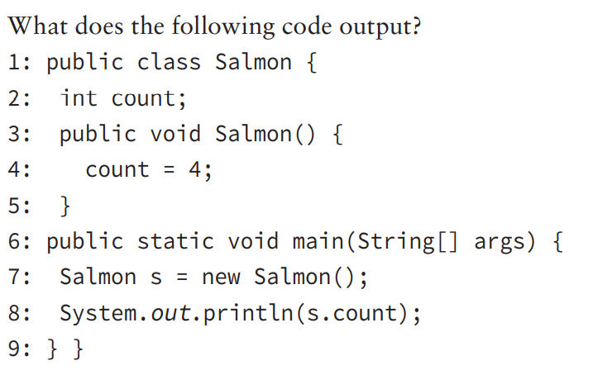
21. What does the code output ?
- 0
- 4
- Compilation fails on line 3
- Compilation fails on line 4
- Compilation fails on line 7
- Compilation fails on line 8
22. Which of the following are true statements ?
- Java allows operator overloading
- Java code compiled on Windows can run on Linux
- Java has pointers to specific locations in memory
- Java is a procedural language
- Java is an object-oriented language
- Java is a functional programming language

23. Which of the following are true ?
- javac compiles a .class file into a .java file
- javac compiles a .java file into a .bytecode file
- javac compiles a .java file into a .class file
- Java takes the name of the class as a parameter
- Java takes the name of the .bytecode file as a parameter
- Java takes the name of the .class file as a parameter

